RETAIL SALES ANALYTICS AND CUSTOMER INTELLIGENCE SYSTEM
A Mini Project Report Submitted in partial fulfillment of the requirements for the award of the degree of

BACHELOR OF TECHNOLOGY
In

DEPARTMENT OF COMPUTER SCIENCE AND ENGINEERING
By
SriHansika Saraf – 2420030556(Teamlead)
J. Madhura – 2420030535
R. Lokesh – 2420030534
G. Charan – 2420080042
Under the Esteemed Guidance of
Dr. K Swapnika





K L (Deemed to be) University

DEPARTMENT OF COMPUTER SCIENCE AND ENGINEERING

DECLARATION

The mini-project report entitled “Retail Sales Analytics and Customer Intelligence System
” is a record of bona fide work carried out by [SriHansika Saraf (2420030556), J. Madhura (2420030535), R. Lokesh (2420030534), and G. Charan (2420080042)] in partial fulfillment of the requirements for the award of the B.Tech degree at K L (Deemed to be) University. The work presented in this report is original to the best of our knowledge, and all datasets, tools, code, and external sources used have been appropriately acknowledged.
SriHansika Saraf - 2420030556
J. Madhura – 2420030535
R. Lokesh – 2420030534
G. Charan – 2420080042

K L (Deemed to be) University

DEPARTMENT OF COMPUTER SCIENCE AND ENGINEERING

CERTIFICATE

This is to certify that the mini-project report entitled “Retail Sales Analytics and Customer Intelligence System” is a bona fide work carried out by [SriHansika Saraf (2420030556), J. Madhura (2420030535), R. Lokesh (2420030534), and G. Charan (2420080042)] under the supervision of [Dr. K Swapnika] during the academic year [2026–2027], in partial fulfillment of the requirements for the award of the Bachelor of Technology degree at K L (Deemed to be) University.

Signature of the Project Supervisor

Signature of the HOD Signature of the External Examiner

ACKNOWLEDGEMENT
The success in this project would not have been possible but for the timely help and guidance rendered by many people. Our wish to express my sincere thanks to all those who has assisted us in one way or the other for the completion of my project.

Our greatest appreciation to my guide, Name of the ALT faculty of respective section, Department of Computer Science which cannot be expressed in words for his/her tremendous support, encouragement and guidance for this project.

We express our gratitude to Dr. P.Venkateshwar Sir (CSE)/Dr. Kaja Shareef Sir (CSIT)/Dr.Sreenath, Head of the Department for Computer Science Engineering/ Department for Computer Science and Information Technology/ Department Of Artificial Intelligence And Data Science for providing us with adequate facilities, ways and means by which we are able to complete this project-based Lab.

We thank all the members of teaching and non-teaching staff members, and also who have assisted me directly or indirectly for successful completion of this project. Finally, I sincerely thank my parents, friends and classmates for their kind help and cooperation during my work.
SriHansika Saraf - 2420030556
J. Madhura – 2420030535
R. Lokesh – 2420030534
G. Charan – 2420080042

TABLE OF CONTENTS

S.No. | Contents | Page no.
1. | Abstract
2. | Introduction
3. | Literature survey
4. | Problem Statement and Objectives
5. | Hardware and Software requirements
6. | Implementation
7. | Results & Discussion
8. | Conclusion & Future Scope
9. | References

ABSTRACT

The Retail Sales Analytics and Customer Intelligence System is an end-to-end data science project developed to analyze retail transactions, predict sales, understand customer behavior, and support data-driven business decisions. The project uses the Global Superstore dataset, containing retail transaction information related to customers, products, orders, shipping, sales, discounts, and profits.
The workflow includes data preprocessing, exploratory data analysis, feature engineering, feature selection, and the development of machine learning and deep learning models. Linear Regression, Decision Tree, Random Forest, and XGBoost are implemented as transaction-level regression models, while LSTM and GRU are evaluated for monthly sales forecasting. Four hybrid configurations are also investigated: LSTM + XGBoost, LSTM + Random Forest, GRU + XGBoost, and GRU + Random Forest.
The proposed LSTM + XGBoost hybrid incorporates an LSTM-derived temporal prediction feature into a transaction-level XGBoost model. In the reported evaluation, the proposed hybrid achieved an MAE of 32.6901, an RMSE of 56.8745, and an R² score of 0.9100. Additional components include RFM-based customer analysis, K-Means clustering, Customer Lifetime Value analysis, discount and quantity scenario analysis, and SHAP- and LIME-based explanations for the standalone XGBoost model. MySQL supports database operations, while Power BI presents interactive dashboards. The project integrates predictive modeling and customer analytics to provide a comprehensive view of retail performance.
Team Name: Batch-9
Team Logo (optional):

Team Members and Responsibilities:

- SriHansika Saraf – Team Leader and Project Execution: Responsible for coordinating team activities, managing project execution, integrating the work, and ensuring timely completion.
- J. Madhura – Research and Data Collection: Responsible for researching the project domain, collecting relevant information, and identifying suitable methods and techniques.
- R. Lokesh – Data Analysis and Implementation: Responsible for assisting with data analysis, implementing project components, and supporting the technical development.
- G. Charan – Documentation and Testing: Responsible for preparing project documentation, testing the implemented components, and verifying the results.
- Global Superstore dataset, Kaggle.
- [Dataset URL / repository URL]

INTRODUCTION

2.1 BACKGROUND
Retail businesses generate large amounts of transactional data containing information about customers, products, orders, discounts, sales, profits, and shipping. Analyzing these records can help organizations understand purchasing behavior, identify profitable products, evaluate regional performance, and improve business planning.
Manual analysis becomes difficult as the volume and complexity of transactional data increase. Data analytics and machine learning provide methods for discovering patterns, evaluating relationships, and predicting outcomes from historical data.
2.2 PROJECT OVERVIEW
The Retail Sales Analytics and Customer Intelligence System uses the Global Superstore dataset to perform descriptive, diagnostic, and predictive analysis. It combines traditional machine learning models, recurrent neural networks, and hybrid modeling to investigate retail sales prediction.
The system also incorporates customer segmentation, Customer Lifetime Value analysis, scenario-based sales prediction, model explainability, SQL queries, and Power BI dashboards.
2.3 TARGET USERS
The intended users include retail analysts, sales managers, business decision-makers, and data analysts who need to understand sales performance, customer behavior, product profitability, and the potential effects of business decisions.
2.4 INPUT AND OUTPUT
Input:
Historical retail transaction data containing order, customer, product, shipping, sales, discount, profit, and geographical information.
Outputs:
Sales predictions, model evaluation metrics, sales trends, customer segments, CLV analysis, scenario-analysis results, feature explanations, and interactive dashboards.
2.5 PROJECT PIPELINE
The project follows these stages:
- Data collection and loading
- Data preprocessing
- Exploratory data analysis
- Feature engineering
- Feature selection
- Machine learning and deep learning
- Hybrid model development
- Model evaluation and comparison
- Customer intelligence and CLV analysis
- Scenario analysis
- Model explainability
- SQL integration
- Power BI dashboard development
The remaining chapters describe related work, project objectives, implementation, experimental results, conclusions, and future improvements.

LITERATURE SURVEY

S.No | Paper Title | Year | Key Focus
1. | Unlocking Retail Insights: Predictive Modeling and Customer Segmentation Through Data Analytics | 2025 | Predictive modeling and customer segmentation using ML
2. | Predictive modeling and customer segmentation using ML | 2025 | Comparison and evaluation of ML models for sales forecasting
3. | Customer Profiling, Segmentation, and Sales Prediction Using AI in Direct Marketing | 2024 | AI-based customer profiling, segmentation and sales prediction
4. | A Dynamic Customer Segmentation Approach by Combining LRFMS and Multivariate Time Series Clustering | 2024 | Dynamic customer segmentation using LRFMS and time-series clustering
5. | Revolutionizing Retail Analytics: Advancing Inventory and Customer Insight with AI | 2024 | AI-based inventory management, customer insights and demand forecasting
6. | Understanding Consumer Behavior in the Retail Sector Using RFM Segmentation and Machine Learning | 2024
  RFM-based customer behavior analysis and ML
7. | An Exploration of Clustering Algorithms for Customer Segmentation in the UK Retail Market | 2024 | Comparison of clustering algorithms for customer segmentation
8. |  | 2024
  Customer Segmentation with Clustering Methods in the Retail Industry
  Clustering techniques and customer-based marketing strategies
9. | Omni-channel Customer Segmentation: A Personalized Customer Journey Perspective | 2024 | Omni-channel customer behavior and personalized segmentation
10. | A Comprehensive Framework for Customer Segmentation and Predictive Analytics | 2025
  Integrated customer segmentation and predictive analytics framework

PROBLEM STATEMENT AND OBJECTIVES

Problem Statement:
Retail organizations need effective methods to analyze historical sales transactions, predict sales, understand customer purchasing patterns, and evaluate the potential impact of business decisions. This project develops a data-driven retail analytics system using machine learning, deep learning, customer analytics, and interactive visualization.

Problem Description:
Retail transaction datasets contain multiple interacting variables related to customers, products, discounts, shipping, and sales. Identifying useful relationships manually is time-consuming and may not provide reliable predictive insights at scale.
The project addresses this challenge by applying data preprocessing, statistical analysis, predictive modeling, customer segmentation, and scenario analysis to the Global Superstore dataset.
Objectives:
- To preprocess and validate the Global Superstore dataset.
- To conduct exploratory data analysis of sales, profit, discounts, products, customers, and regions.
- To create relevant features and select suitable predictors for sales modeling.
- To implement and evaluate Linear Regression, Decision Tree, Random Forest, and XGBoost regression models.
- To implement LSTM and GRU models for monthly sales forecasting.
- To develop and compare four hybrid configurations combining LSTM or GRU with XGBoost or Random Forest.
- To evaluate model performance using MAE, MSE, RMSE, R², MAPE, and SMAPE.
- To perform RFM-based customer analysis and K-Means clustering.
- To conduct Customer Lifetime Value analysis.
- To evaluate discount and quantity scenarios using the implemented prediction workflow.
- To interpret standalone XGBoost predictions using SHAP and LIME.
- To store and analyze data using MySQL.
- To develop interactive Power BI dashboards for communicating analytical findings.

HARDWARE AND SOFTWARE REQUIREMENTS
Hardware Requirements:
• Computer or laptop with a modern multi-core processor.
• Recommended minimum of 8 GB RAM.
• Sufficient storage for datasets, model files, output workbooks, and visualizations.
• Internet connection for downloading datasets and software packages.
• GPU is optional for the implemented classical machine learning models.

Software Requirements:

• Operating System: Windows.
• Programming Language: Python 3.x.
• Development Environment: Visual Studio Code.
• Data Processing: Pandas and NumPy.
• Visualization: Matplotlib and Seaborn.
• Machine Learning: Scikit-learn.
• Gradient Boosting: XGBoost.
• Deep Learning: TensorFlow/Keras.
• Model Explainability: SHAP and LIME.
• Database: MySQL.
• Database Interface: MySQL Workbench.
• Dashboard Development: Microsoft Power BI.
• Version Control: Git and GitHub.

IMPLEMENTATION

6.1 DATA LOADING AND PREPROCESSING
The Global Superstore dataset is loaded using Pandas. The initial inspection includes the number of rows and columns, data types, missing values, duplicates, and descriptive statistics.
Preprocessing activities include:
• Loading and inspecting the dataset.
• Converting Order Date and Ship Date into appropriate date formats.
• Checking missing values.
• Detecting duplicate records.
• Examining numerical distributions and potential outliers.
• Removing the Postal column as specified in the project workflow.
• Saving the preprocessed dataset.
The validated preprocessing output contains 51,290 records, with no missing values and no duplicate records.
Implementation File: src/preprocessing.py
Output Folder: outputs/01_Preprocessing
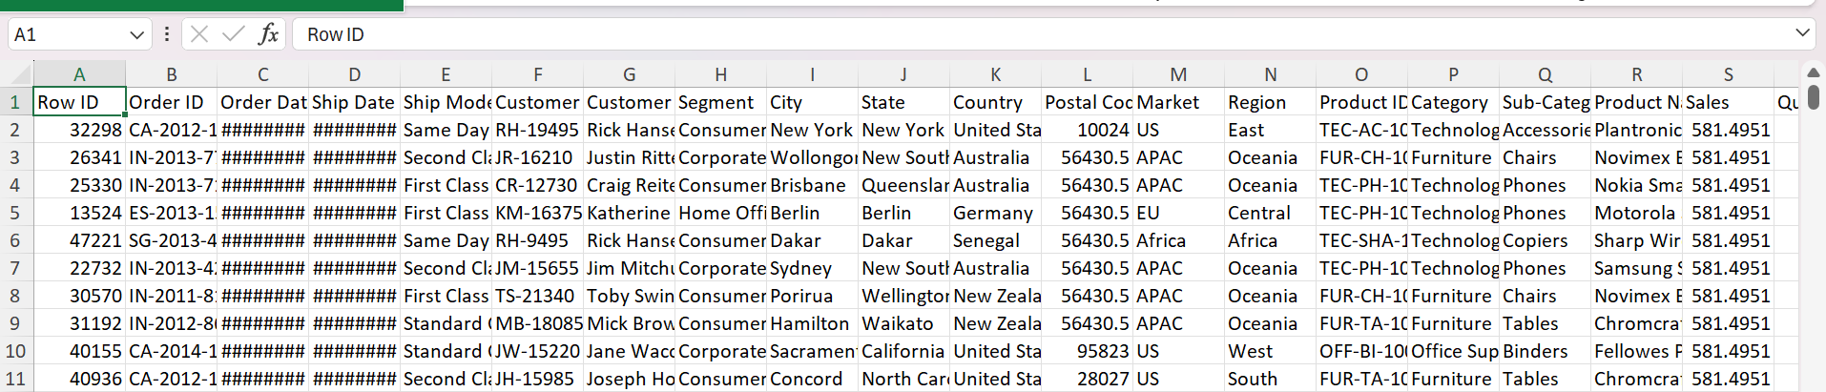
6.2 EXPLORATORY DATA ANALYSIS
Exploratory Data Analysis is used to understand the structure, distributions, and relationships in the retail dataset.
The analyses include:
• Dataset overview and descriptive statistics.
• Univariate analysis.
• Bivariate analysis.
• Multivariate analysis.
• Correlation analysis.
• Sales trend analysis.
• Customer behavior analysis.
• Product performance analysis.
• Regional performance analysis.
• Profit analysis.
• Discount analysis.
• Customer segmentation analysis.
The results are represented through charts, statistical summaries, and Excel workbooks.
Implementation File: src/eda.py
Output Folder: outputs/02_EDA/
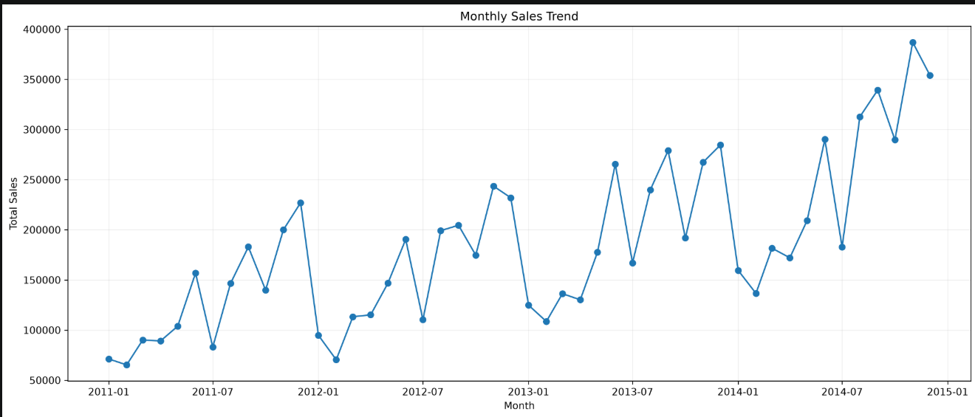
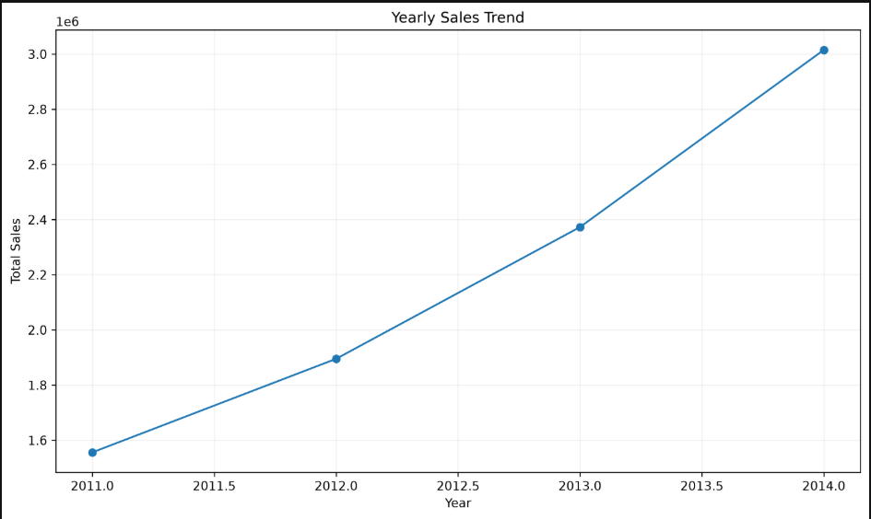
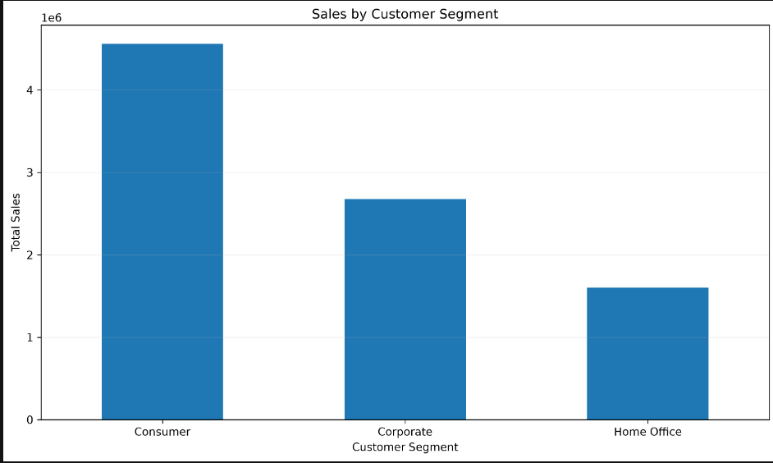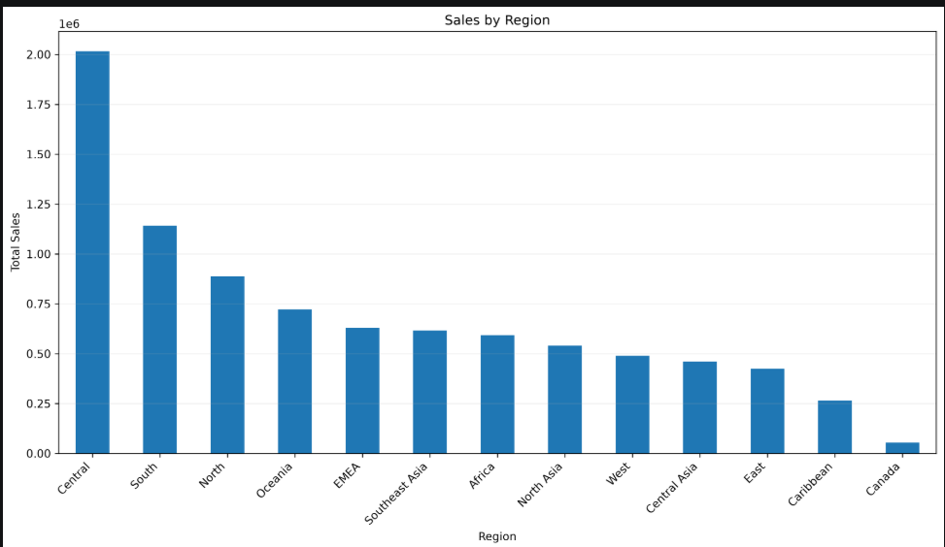
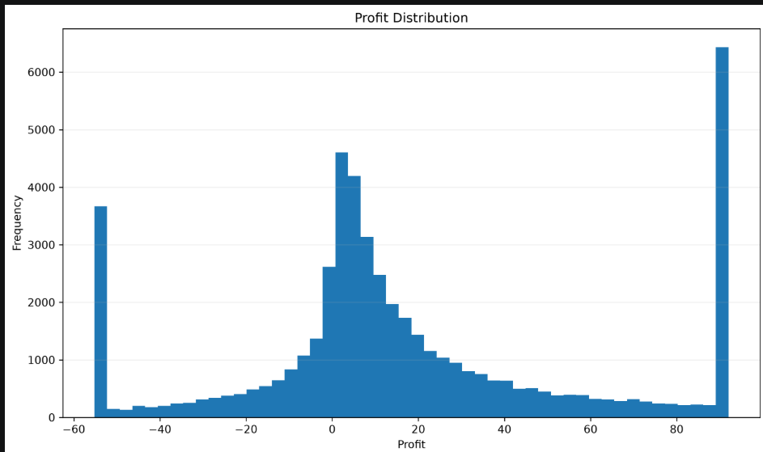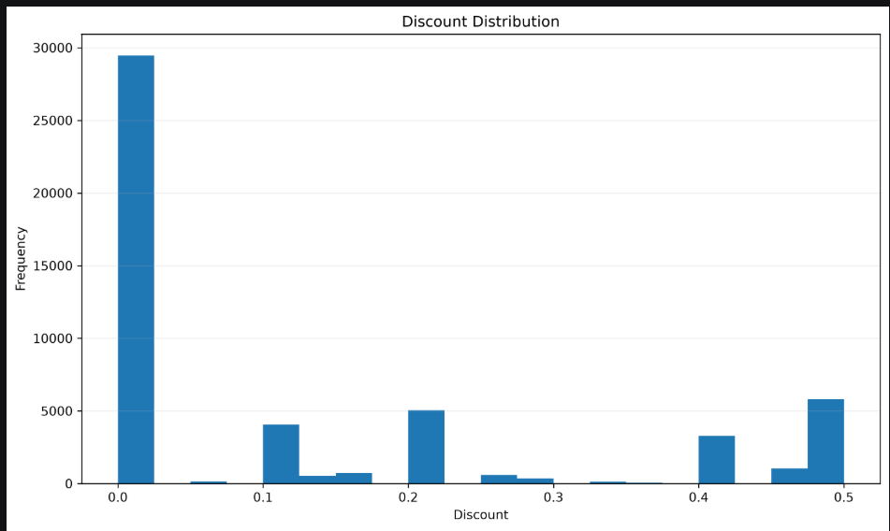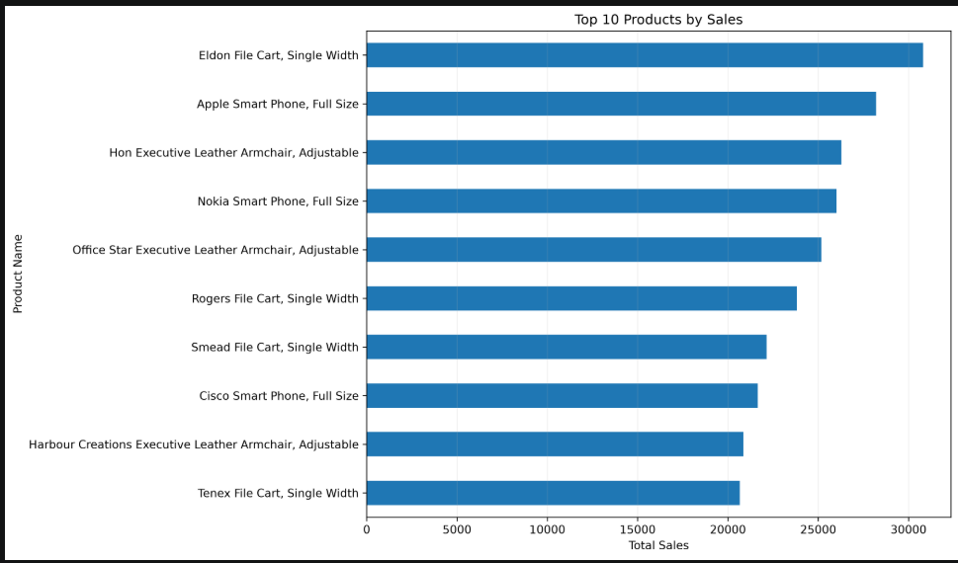

6.3 FEATURE ENGINEERING
Feature engineering creates additional variables from the existing transaction data to improve the analytical and predictive workflow.
The feature groups include:
• Date-related features such as order year, month, quarter, and day of the week.
• Customer-related variables.
• Product and category variables.
• Shipping-related variables.
• Sales, quantity, discount, and profit-related variables.
The exact engineered features are documented according to the implemented code.
Implementation File: src/feature_engineering.py
Output Folder: outputs/03_Feature_Engineering/
6.4 FEATURE SELECTION
Feature selection evaluates candidate predictors and prepares the features used for model training.
The workflow includes correlation analysis, numerical feature screening, categorical feature screening, and feature-importance analysis.
The selected features are used in the subsequent model-development workflow.
Implementation File: src/feature_selection.py
Output Folder: outputs/04_Feature_Selection/
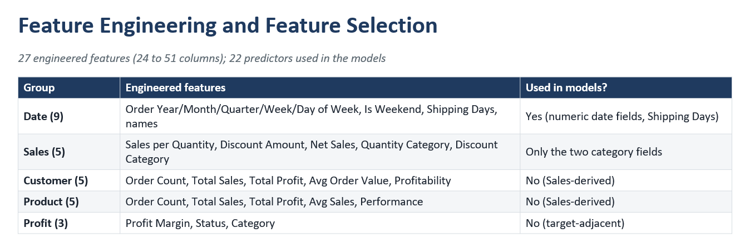
6.5 MACHINE LEARNING MODELS
The project implements four transaction-level regression models.
A. Linear Regression
Linear Regression is used as a baseline model to estimate sales using the selected transaction features.
B. Decision Tree Regressor
The Decision Tree Regressor captures nonlinear relationships through a set of learned decision rules.
C. Random Forest Regressor
Random Forest combines predictions from multiple decision trees to model complex relationships and reduce reliance on a single tree.
D. XGBoost Regressor
XGBoost uses gradient boosting to build a sequence of decision trees and capture complex relationships between predictors and sales.
The models are trained and evaluated using the implemented training and testing workflow.
Implementation File: src/machine_learning.py
Output Folder: outputs/05_Machine_Learning/

6.6 DEEP-LEARNING MODELS
A. Long Short-Term Memory (LSTM)
LSTM is a recurrent neural network architecture used to learn temporal dependencies from monthly sales observations.
The implementation aggregates sales by month, prepares sequential inputs, trains the model, and evaluates its monthly forecasting performance.
B. Gated Recurrent Unit (GRU)
GRU is another recurrent neural network architecture used to learn temporal patterns in monthly sales data.
The implementation follows the monthly forecasting workflow and produces evaluation results for comparison.
The report distinguishes monthly forecasting metrics from transaction-level regression metrics because the models operate at different levels.
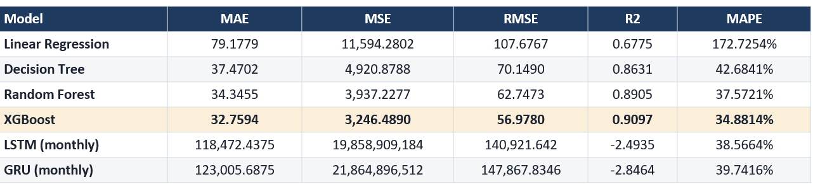
6.7 HYBRID MODEL DEVELOPMENT
The project evaluates four hybrid configurations:
- LSTM + XGBoost
- LSTM + Random Forest
- GRU + XGBoost
- GRU + Random Forest
The proposed hybrid, referred to as TATFF-XGBLSTM in the project presentation, uses an LSTM-derived temporal prediction as an additional feature for a transaction-level XGBoost model.
The implementation involves preparing monthly sales data, generating temporal predictions, incorporating the temporal feature into transaction-level predictors, training the downstream model, and evaluating the predictions.
The hybrid configurations are compared with the standalone machine learning and deep-learning models.
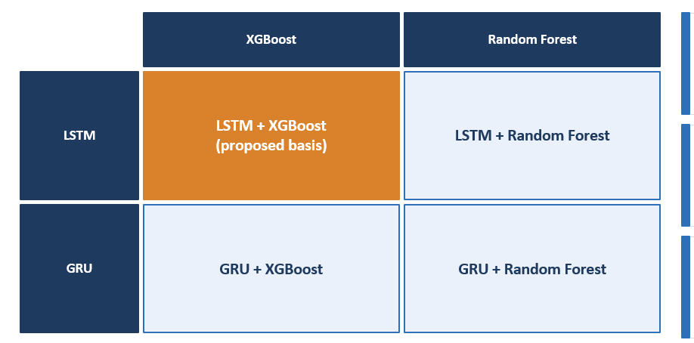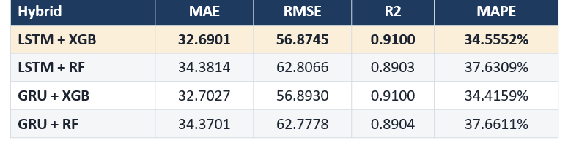
6.8 MODEL EVALUATION
The implemented regression metrics are:
• Mean Absolute Error (MAE)
• Mean Squared Error (MSE)
• Root Mean Squared Error (RMSE)
• R² Score
• Mean Absolute Percentage Error (MAPE)
• Symmetric Mean Absolute Percentage Error (SMAPE)
Lower MAE, MSE, RMSE, MAPE, and SMAPE values generally indicate smaller prediction errors. A higher R² score generally indicates a better fit relative to a mean-prediction baseline.
The project uses the Silhouette Score to evaluate the tested K-Means cluster counts.
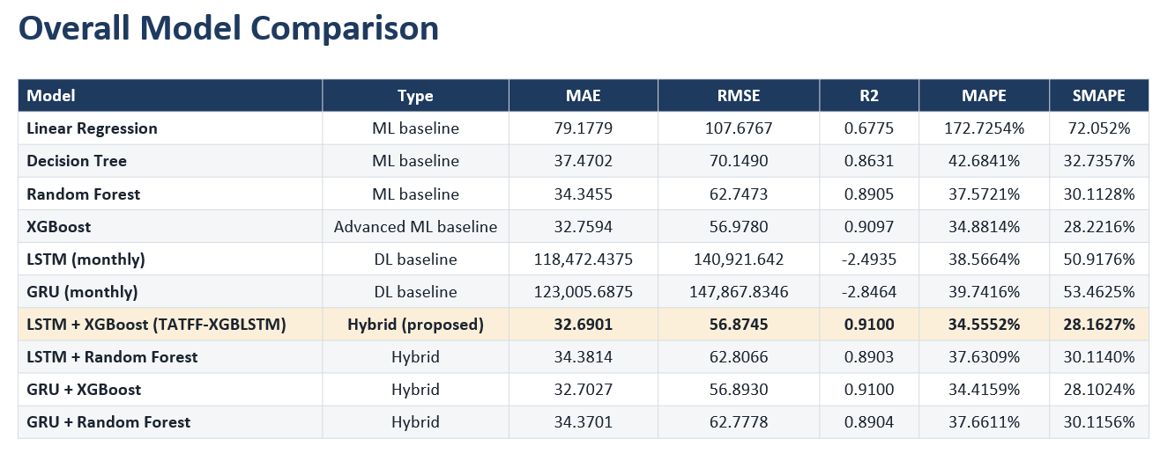
6.9 CUSTOMER INTELLIGENCE
RFM-based customer analysis evaluates customer recency, frequency, and monetary value.
K-Means clustering is used to group customers according to the features supplied to the clustering workflow. The tested cluster counts are compared using silhouette scores.
The implemented analysis supports the examination of customer behavior and customer-value groups.
Implementation File: src/rfm_analysis.py
Output Folder: outputs/07_Customer_Intelligence/
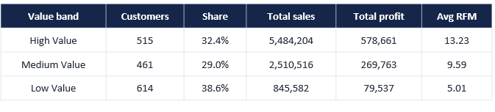
6.10 CUSTOMER LIFETIME VALUE ANALYSIS
The CLV component analyzes customer value using the project's implemented customer-level calculations.
It supports the identification and comparison of customer-value groups and provides results for customer-focused reporting.
Implementation File: src/clv_analysis.py
Output Folder: outputs/08_CLV/
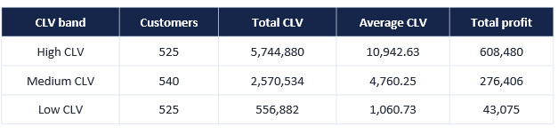
6.11 SCENARIO ANALYSIS
A. Discount Scenario Analysis
The discount scenario workflow varies the discount input and evaluates the resulting predicted sales.
B. Quantity Scenario Analysis
The quantity scenario workflow varies quantity and evaluates the resulting predicted sales.
These scenarios support what-if analysis and allow users to compare model predictions under different input assumptions.
Implementation Files:
src/discount_scenario.py
src/quantity_scenario.py
Output Folder: outputs/09_Scenario_Analysis/
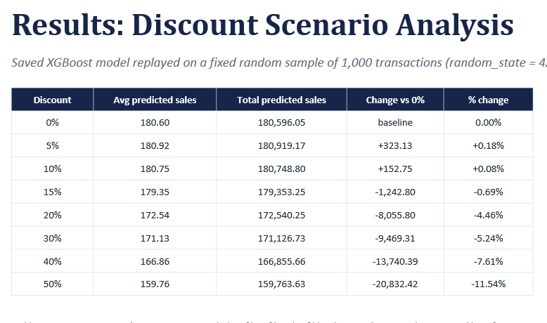
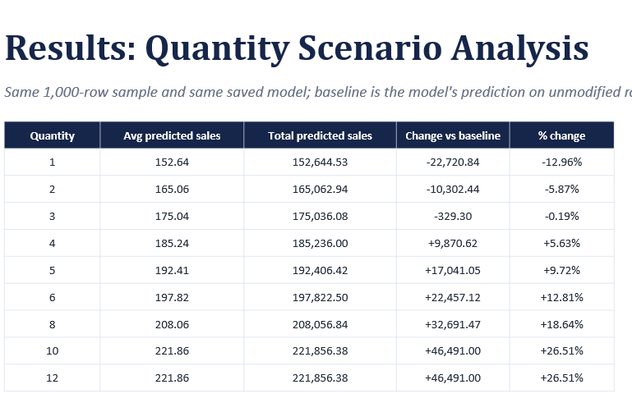
6.12 MODEL EXPLAINABILITY
A. SHAP
SHAP is used to examine the contribution of features to predictions from the standalone XGBoost sales-prediction model.
Implemented outputs include feature-importance results and visualizations.
B. LIME
LIME is used to explain individual predictions by approximating the model's behavior around selected instances.
The project generates local explanation outputs for analysis and reporting.
The current SHAP and LIME outputs explain the standalone XGBoost model, not the proposed hybrid model.
Implementation File: src/model_explainability.py
Output Folder: outputs/10_Model_Explainability/
6.13 SQL DATABASE INTEGRATION
MySQL is used to store and query retail sales data.
The database is named retail_analytics, and the sales table is named sales_data.
The SQL workflow includes:
• Retrieving records using SELECT.
• Filtering records using WHERE.
• Grouping records using GROUP BY.
• Calculating aggregate sales and profit.
• Generating analytical summaries.
Implementation Files:
src/sql_database.py
src/sql_analysis.sql
6.14 POWER BI DASHBOARD
The Power BI dashboard presents the project's analytical and predictive results through seven pages.
- Overview
- Product & Profit Analysis
- Customer Intelligence
- Customer CLV
- Scenario Analysis
- Model Explainability
- ML Model Comparison
The dashboard combines key performance indicators, charts, customer analysis, scenario results, model evaluation metrics, and explainability visualizations.
The Model Explainability page presents SHAP and LIME results for the standalone XGBoost model.

RESULTS AND DISCUSSION
7.1 PREPROCESSING RESULTS
The preprocessed dataset contains 51,290 records. The validation output reports no missing values and no duplicate records.
7.2 MACHINE LEARNING RESULTS
The reported results for the transaction-level regression models are:
Linear Regression:
MAE = 79.1779
MSE = 11594.2802
RMSE = 107.6767
R² = 0.6775
MAPE = 172.7254%
SMAPE = 72.052%
Decision Tree:
MAE = 37.4702
MSE = 4920.8788
RMSE = 70.1490
R² = 0.8631
MAPE = 42.6841%
SMAPE = 32.7357%
Random Forest:
MAE = 34.3455
MSE = 3937.2277
RMSE = 62.7473
R² = 0.8905
MAPE = 37.5721%
SMAPE = 30.1128%
XGBoost:
MAE = 32.7594
MSE = 3246.4890
RMSE = 56.9780
R² = 0.9097
MAPE = 34.8814%
SMAPE = 28.2216%
7.3 DEEP-LEARNING AND HYBRID RESULTS
LSTM:
MAE = 118472.4375
MSE = 19858909184.0
RMSE = 140921.6420
R² = -2.4935
MAPE = 38.5664%
SMAPE = 50.9176%
GRU:
MAE = 123005.6875
MSE = 21864896512.0
RMSE = 147867.8346
R² = -2.8464
MAPE = 39.7416%
SMAPE = 53.4626%
LSTM + XGBoost:
MAE = 32.6901
MSE = 3234.7106
RMSE = 56.8745
R² = 0.9100
MAPE = 34.5552%
SMAPE = 28.1627%
LSTM + Random Forest:
MAE = 34.3814
MSE = 3944.6709
RMSE = 62.8066
R² = 0.8903
MAPE = 37.6309%
SMAPE = 30.1140%
GRU + XGBoost:
MAE = 32.7027
MSE = 3236.8164
RMSE = 56.8930
R² = 0.9100
MAPE = 34.4159%
SMAPE = 28.1024%
GRU + Random Forest:
MAE = 34.3701
MSE = 3941.0504
RMSE = 62.7778
R² = 0.8904
MAPE = 37.6611%
SMAPE = 30.1156%
7.4 DISCUSSION OF MODEL PERFORMANCE
XGBoost performs strongly among the standalone transaction-level models. The LSTM + XGBoost hybrid produces a slightly lower MAE and RMSE than the standalone XGBoost model in the reported experiment.
The proposed hybrid achieved an MAE of 32.6901, an RMSE of 56.8745, and an R² score of 0.9100. GRU + XGBoost achieved slightly lower MAPE and SMAPE, so the proposed hybrid should not be described as best on every metric.
The monthly LSTM and GRU baselines have substantially different error magnitudes because they predict monthly aggregated sales rather than individual transactions. Their metrics should not be directly interpreted as an equivalent transaction-level comparison.
7.5 CUSTOMER SEGMENTATION RESULTS
K-Means clustering was evaluated for cluster counts from k = 2 to k = 6.
Reported Silhouette Scores:
k = 2: 0.666635
k = 3: 0.554768
k = 4: 0.506601
k = 5: 0.355589
k = 6: 0.353201
The implemented comparison selected k = 2 because it achieved the highest silhouette score among the tested values.
7.6 CUSTOMER VALUE AND SCENARIO ANALYSIS
RFM-based analysis and CLV analysis are used to examine customer behavior and customer value.
Discount and quantity scenarios evaluate the effects of changing selected inputs on predicted sales. The results are presented in the scenario-analysis outputs and Power BI dashboard.
7.7 MODEL EXPLAINABILITY RESULTS
SHAP provides global feature-importance information, while LIME provides local explanations for individual predictions. The current explanations are generated for the standalone XGBoost model.
7.8 POWER BI RESULTS
The Power BI dashboard organizes the project outputs into seven pages: Overview, Product & Profit Analysis, Customer Intelligence, Customer CLV, Scenario Analysis, Model Explainability, and ML Model Comparison.
Relevant dashboard screenshots should be inserted into the final report, with a short explanation below each figure.

CONCLUSION AND FUTURE SCOPE

8.1 CONCLUSION
The Retail Sales Analytics and Customer Intelligence System integrates data preprocessing, exploratory analysis, feature engineering, machine learning, deep learning, hybrid modeling, customer intelligence, CLV analysis, scenario analysis, explainability, SQL, and Power BI.
Four transaction-level machine learning and two monthly deep-learning baselines are evaluated, together with four hybrid configurations. In the reported results, the LSTM + XGBoost hybrid achieves an MAE of 32.6901, an RMSE of 56.8745, and an R² score of 0.9100. Its improvements over standalone XGBoost are modest, while GRU + XGBoost performs slightly better on MAPE and SMAPE.
The additional customer analytics, scenario-analysis, database, and dashboard components support broader analysis of retail transactions and customer behavior.
8.2 FUTURE SCOPE
• Evaluating models using multiple time-based train-test splits.
• Conducting statistical significance testing of performance differences.
• Exploring additional temporal and transaction-related features.
• Evaluating further hybrid architectures based on clearly defined research questions.
• Extending explainability to the proposed hybrid model.
• Improving the robustness of scenario-analysis assumptions.
• Investigating multilingual or more diverse retail datasets.
• Exploring automated model monitoring and periodic retraining.
• Enhancing customer-value analysis with additional validated customer behavior measures.

REFERENCES

- Global Superstore dataset. Kaggle. [Insert the exact dataset URL and verified access date.]
- Research paper on retail sales forecasting using machine learning. [Insert complete citation and DOI/URL.]
- Research paper on LSTM-based time-series forecasting. [Insert complete citation and DOI/URL.]
- Research paper on GRU-based time-series forecasting. [Insert complete citation and DOI/URL.]
- Research paper on XGBoost-based forecasting. [Insert complete citation and DOI/URL.]
- Research paper on hybrid machine-learning and deep-learning forecasting. [Insert complete citation and DOI/URL.]
- Research paper on RFM-based customer segmentation. [Insert complete citation and DOI/URL.]
- Research paper on Customer Lifetime Value analysis. [Insert complete citation and DOI/URL.]
- Scikit-learn documentation. https://scikit-learn.org/stable/
- XGBoost documentation. https://xgboost.readthedocs.io/
- TensorFlow documentation. https://www.tensorflow.org/
- SHAP documentation. https://shap.readthedocs.io/
- LIME documentation. https://lime-ml.readthedocs.io/
- MySQL documentation. https://dev.mysql.com/doc/
- Microsoft Power BI documentation. https://learn.microsoft.com/power-bi/
- Project GitHub repository. https://github.com/SriHansika-04/KLH-CSE-2026-27-2420030556-RetailAnalytics.git

